BM 538

Computational Neuroscience

Project:

Reaction Time Analysis

Experimentor:

Kerem Kurban

Submitted to:

Burak Güçlü

Sevgi Öztürk

Experiment Date:

22-29.09.2017

Results

Reaction time analysis,a well-known experiment by Treismen and Gelade(1980) is a set of trials in which it is expected to have increasing delay in reaction time where distractor size increase in conjunction search, but not in pop-out search. Here, I replicated this experiment using MATLAB 2014 with a laptop having 8gb ddr3 ram, intel i7 5th generation processor.

The expected graph where stimuli is present in pop-out and conjunction search is given in *figure 1.* Also, as can be seen in *figure 2,*in the case of conjunction search *r*eaction Time (RT) increases over set size for all conditions, let it be target-present or target-absent just like those in *figure 1.*(p=0.01 for target-present, p=0.03 for target absent). Similarly, pop-out search reaction times are mostly kept at similar levels.(p = 0.39 for target present, p=0,45 for target absent)

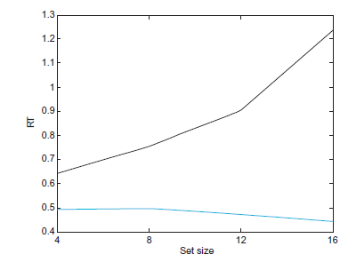

Figure 1: Expected results from Matlab for Neuroscientists book.1

For target-absent cases, it was observed that both pop-out and conjunction reaction times were delayed compared to those of target-present. Participants stated that they searched out more for the target in target-absent cases in case there may be a blue circle among the stimuli. All these results suggest that the experiment was a success and reaction times are independent of set sizes for pop-out search, but not for conjunction.

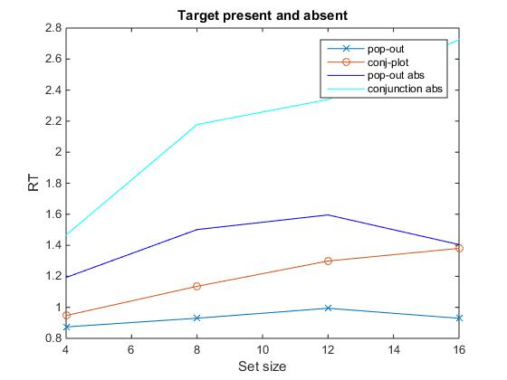

Figure 2: Reaction times vs. Setsize (4,8,12,16) from sample size of 2 people, both female & drug-naive

Table 1: Pearson correlation coefficients and p values for pop-out & conjunction searches (target present/absent)

|  |  |  |
| --- | --- | --- |
| pop_out | p value | 0.394040 |
|  | pearson correlation coef | 0.605960 |
| conjunction | p value | 0.013800 |
|  | pearson correlation coef | 0.986200 |
| pop_out/target absent | p value | 0.453581 |
|  | pearson correlation coef | 0.546419 |
| conjunction/target absent | p value | 0.034609 |
|  | pearson correlation coef | :  0.965391 |

References

1. Pascal Wallisch, Michael E. Lusignan, Marc D. Benayoun, Tanya I. Baker, Adam Seth Dickey and Nicholas G. Hatsopoulos , Matlab for Neuroscientists, 1st edition ,ISBN: 978-0-12-383836-0